ADHD Task Manager

Beta Testing Feedback Review

### Table of Contents:

Introduction

How the testers rated the applications UI

How did the testers rate the performance of the application

How did the testers rate the functionality of the application

What our testers liked about the application

What our testers did not like about the application

We asked our testers for three things they would like to see improved

Did our testers experience any bugs with the UI

Did our testers experience any crashes

We asked our testers if they and any other feedback

## Introduction

This document explores the feedback that was gathered from testers after the first round of out beta testing. This document includes the responses from our testers, as well as graphs to display common trends in the feedback from our testers.

## How the testers rated the applications UI

*The below graph is scale from unusable (1) to very usable (10).*

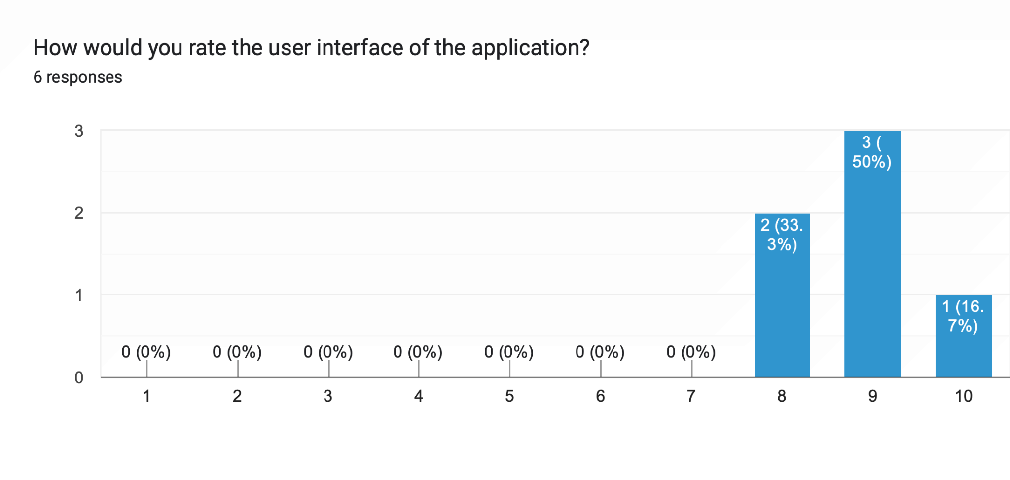

From a total of **six** responders, we can see the overall feedback from our testers is that the applications user interface was relatively well received. All our testers rated the applications user interface an 8 or above.

## How did the testers rate the performance of the application

*The scale of the graph below is from poor (1) to very good (10)*

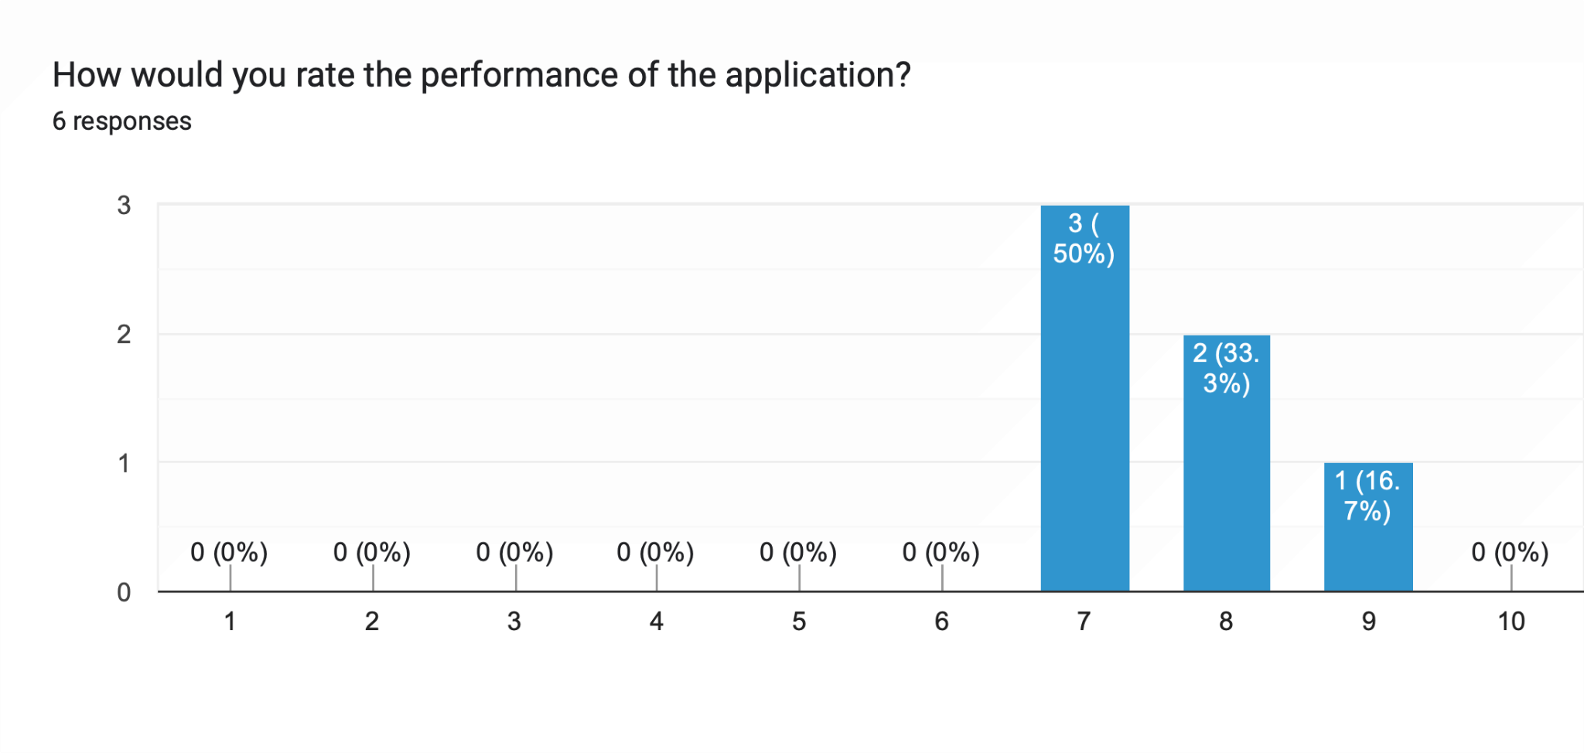

From a total of **six** responders, all of our testers rated the applications performance a 7 or above, indicating that the application performed well on our testers devices.

## How did the testers rate the functionality of the application

*The scale of the graph below is from Did not work as expected (1) to Worked as expected (5).*

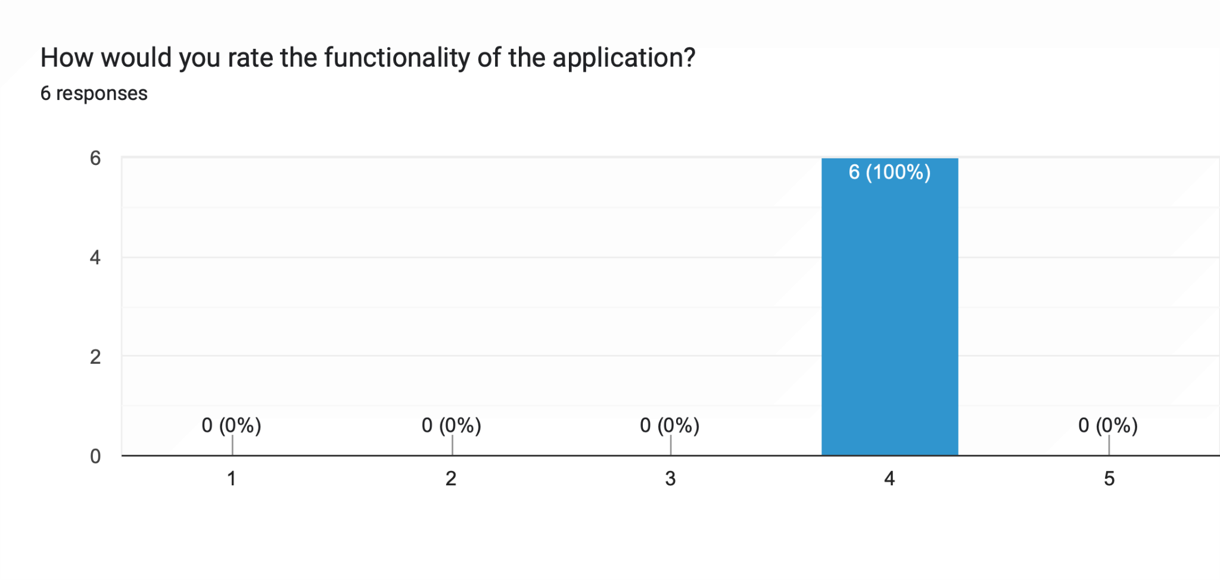

From a total of **six** responders, all our testers rated the applications functionality as a 4 out of 5, which indicates that our testers were largely happy with the functionality of the application, with some improvements that could be made.

## What our testers liked about the application

|  |
| --- |
| The designs colours were fun and the usability of the app was easy enough to pick up straight away. |
| I liked how clean the design was, nothing was cramped or overcrowded. |
| I liked the leaderboard incorporation, it was a fun way of interacting with the app and made me want to complete another task. |
| I liked the simplicity of the design |
| The design was nice, and easy to use. |
| I thought the app was really easy to use. The design also looked good. |

The feedback suggest that our tester felt that the application was easy to use, and that the user interface was clutter free, simple and visually appealing.

## What our testers did not like about the application

|  |
| --- |
| When first starting off I was unsure of what to click first. It took me a moment to find the help page to read how it works. A small helpful hint at the start would be nice on what to click. |
| Some parts of the app didn't change to dark mode when I toggled it on, in the completed task, rewards and leaderboard pages. The buttons for the timer were a little bit small for me. |
| I thought the adding a task page could be a little bit more aesthetic (the page that comes up when you have clicked the plus button. I felt like it didn't exactly match the aesthetic of the rest of the app. Maybe it should be a pop up over the home screen instead of a whole page. Also I feel the selecting a time for the task isn't very responsive. A scroll wheel for the time could be more appropriate. |
| Things I didn't like will be in my list of 3. |
| The welcome message popping up every time I opened the application, it would have been nice if it only did that the first time I opened the application for the day. The dark mode was a little broken on the leaderboard and rewards screens. |
| N/A. |

The feedback suggest that our tester felt that the application needed a tutorial or hint of how to navigate the application. The feedback also points out some inconsistencies with the UI, with the Add/Edit task UI not being consistent with the rest of the application. There were also several mentions of the dark mode not working correctly on a few of the screens.

## We asked our testers for three things they would like to see improved

*Our testers were asked to list three things that felt needed improvement in order of most to least important to them.*

|  |
| --- |
| 1- my reward didn't add up correctly. I had 7 task completion but 27 points.  2 - It took a me a while to figure out how to add a task the first time |
| 1. The dark mode on the rewards, completed and leaderboard pages.  2. Make the buttons on the timer page bigger.  3. A little tutorial when you first sign in that tells you how to add a task, that you can swipe to open and close the menu. |
| - The adding a task page  -The time feature on adding a task  - Signing out of the app crashed the app when trying to log back in |
| 1. Change the time setting from a clunky clock where users have to move the hands to one where they can just type their time.  2. Change the initial loading page to a few seconds shorter.  3. Fix the set out of words so the s isnt on another line. |
| 1. Make the welcome message only pop up the first time the app is opened per day.  2. Fix the dark mode on the leaderboard and rewards screens.  3. Maybe add a few more welcome messages so that there is a bit of variety. |
| I just have one thing I think could be improved, and that is to make some of the button a little bit bigger, such as the date, time buttons when making a new task. |

## Did our testers experience any bugs with the UI

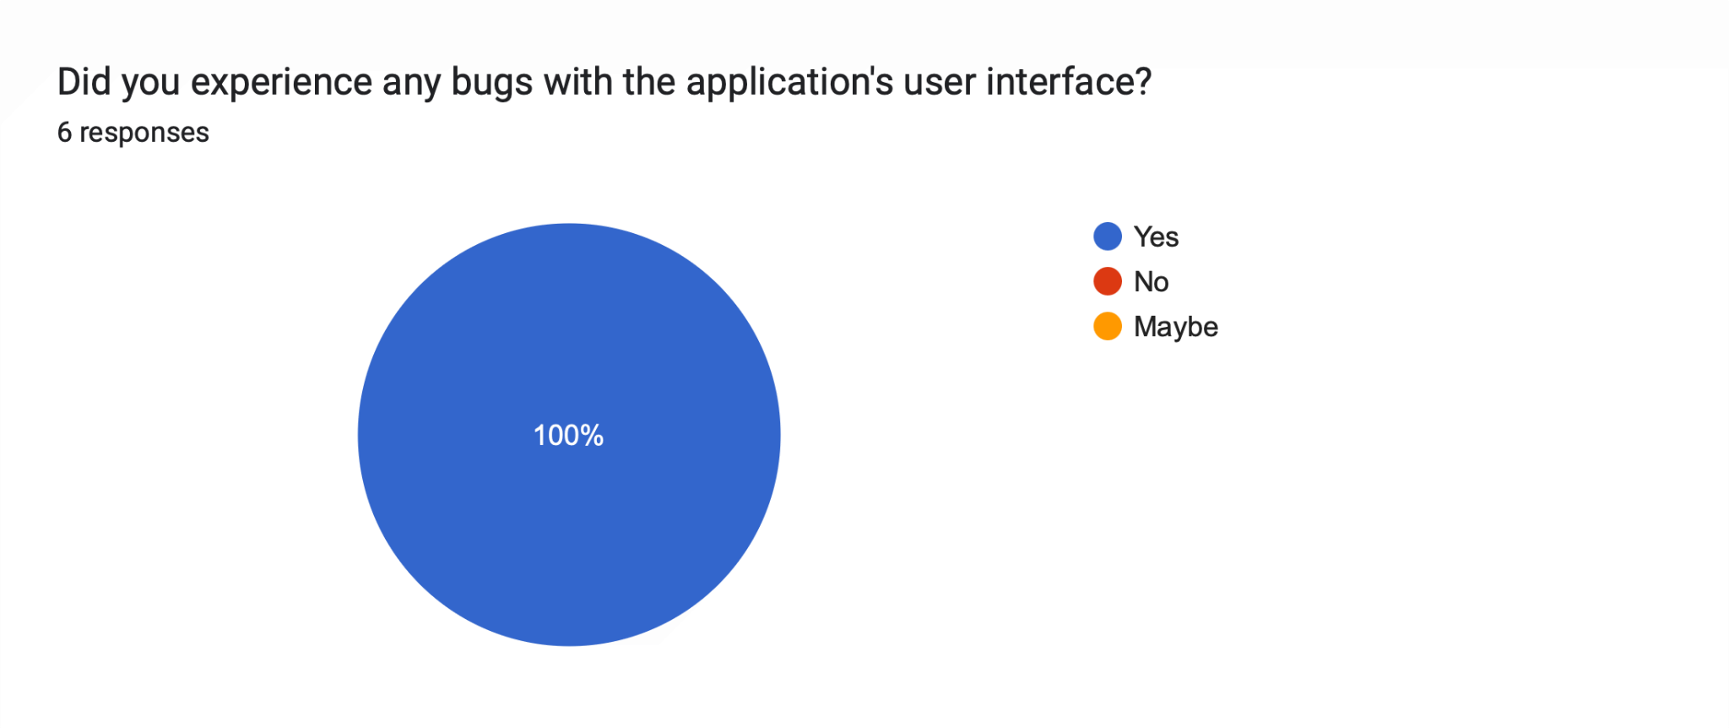

All **six** of our responders answered yes to this question, with their reasons explained by them in the responses below.

|  |
| --- |
| The rewards points didnt add up correctly. |
| The rewards points didn't match up with what I had earned by completing tasks and logging in. |
| The app crashed when on the first try of signing back in once I had signed out. |
| The rank page had a huge list one day of repeating users, but this changed when i logged out and back in. Also the settings would not display the full page, this was consistently happening after logging off. |
| The dark mode as mentioned in the previous section. |
| The rewards points didn't match what I should have had by completing the testing task. |

## Did our testers experience any crashes

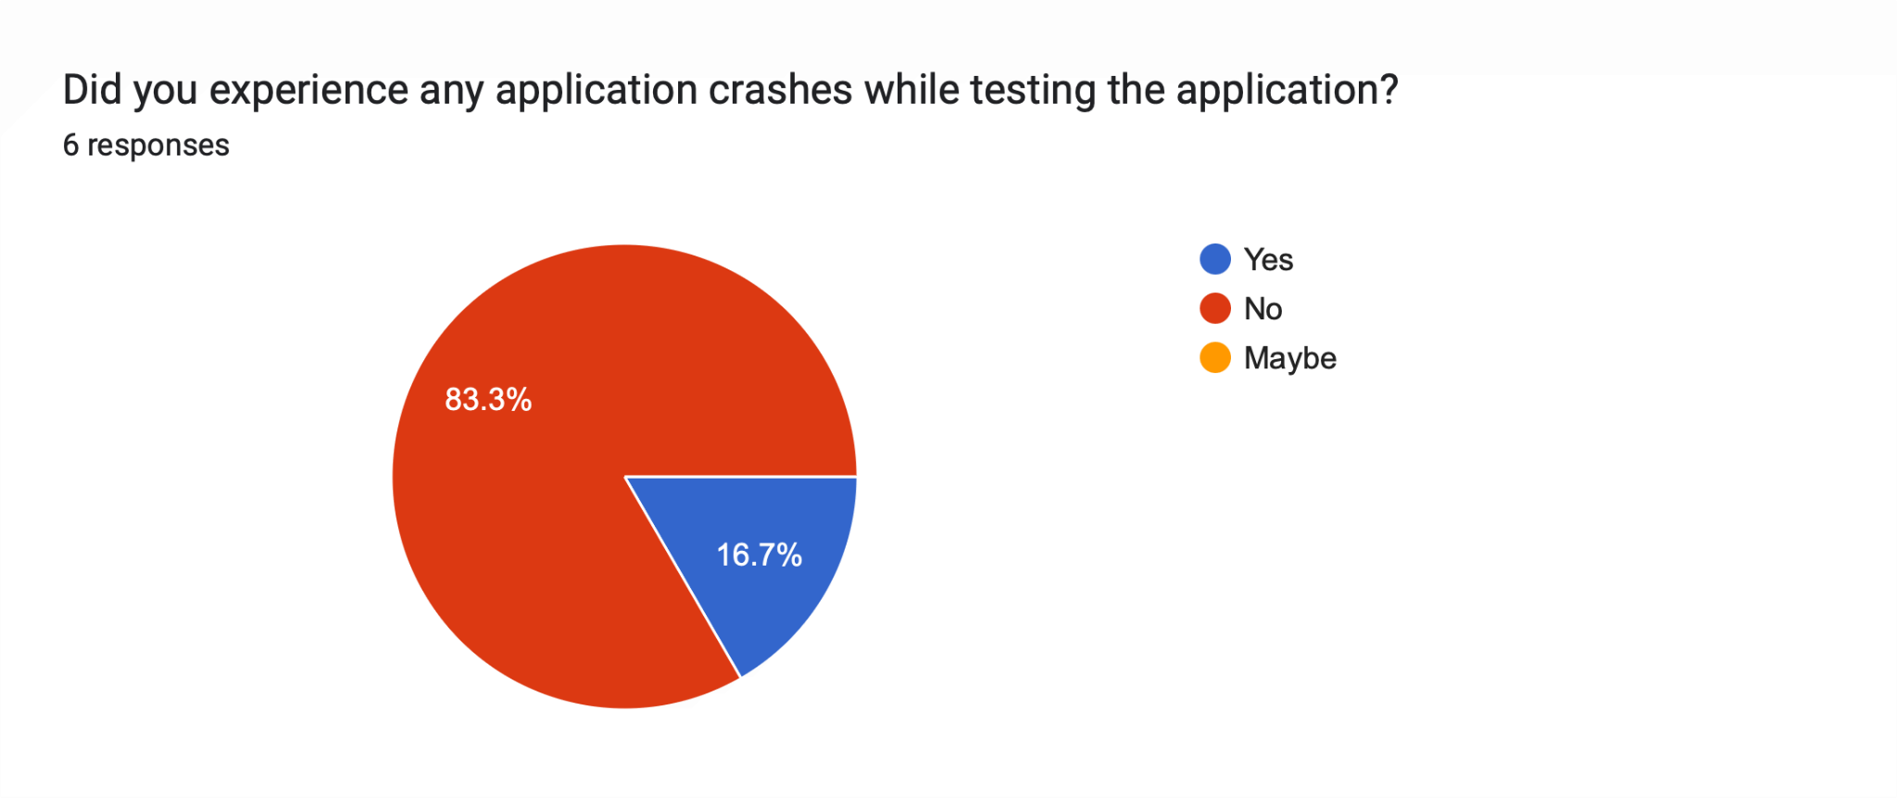

1 of our **six** responders responded yes to this question, with their reason explained in the response below.

|  |
| --- |
| The app crashed when on the first try of signing back in once I had signed out. |

## We asked our testers if they and any other feedback

We asked all our testers if they had any other feedback for us about the application, two of our testers responded with the following responses.

|  |
| --- |
| Great app, would definitely recommend to someone with the condition. |
| Matt will send you screenshots cos they won't attach here. |